
Lab Report 05
Data Communication & Computer Networks


Submitted To:
Engineer Shehzad Malik
Submitted By:
Sumama Rahim
F24BSCS039
BS CS (F24-A-Morning)
Date: 11/20/2025
LAB REPORT – 05
Cisco Packet Tracer – Dynamic Routing – version 2 (RIP)

Problem:
Make 4 router topology with 2 PCs and ping it and do network advertised missing IPs dynamically.
Solution:
Required Resources:
- 2 PCs
- 4 Routers
- Serial 0/0 interface, Serial 0/1
- FastEthernet 0/0 interface
Topology
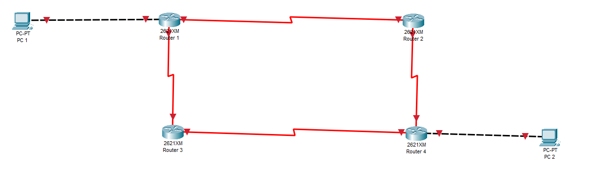

NOTE:
Addresses:
Network 1 (Router 1 and Router 2): S 0/0 1.1.1.1 and 1.1.1.2 (Via serial DCE cable)
Network 2 (Router 1 and Router 3): S 0/1 2.1.1.1 and 2.1.1.2 (Via serial DCE cable)
Network 3 (Router 3 and Router 4): S 0/0 3.1.1.1 and 3.1.1.1 (Via serial DCE cable)
Network 4 (Router 2 and Router 4): S 0/1 4.1.1.1 and 41.1.1.2 (Via serial DCE cable)
Network 5 (Router 1 and PC 1): F 0/0 10.10.10.10 and 10.10.10.11 (Via copper cross over cable)
Network 6 (Router 4 and PC 2): F 0/0 20.1.1.1 and 20.1.1.2 (Via copper cross over cable)

Hardware Setup:
To enter serial interface, first we need to switch OFF of all routers and insert WIC-2T card in it and then switch ON.
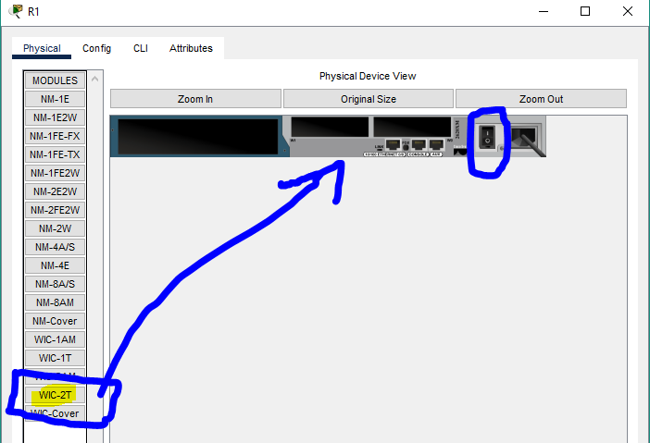

It should be inserted like this
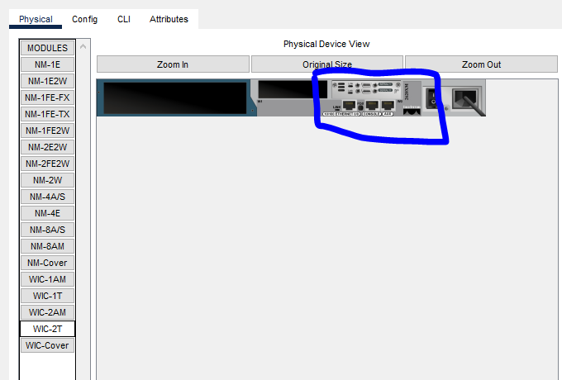

Task 1: Setting up IP addresses

For Router1 (Serial 0/0, Serial 0/1 and FastEthernet 0/0)

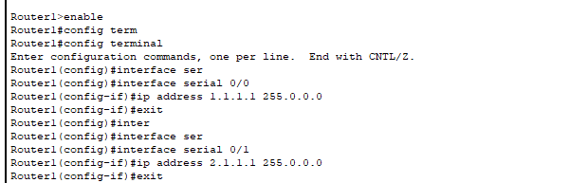
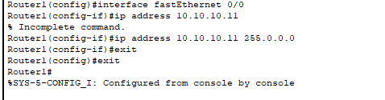

Showing IP addresses

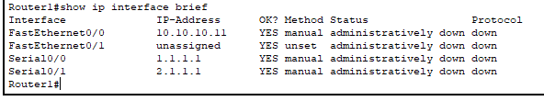

For Router2 (Serial 0/0 and Serial 0/1)

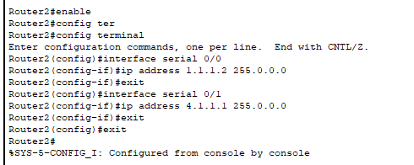

Showing IP address
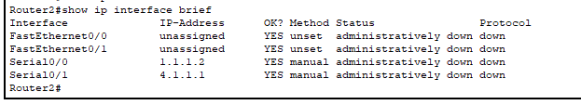

For Router3 (Serial 0/0 and Serial 0/1)

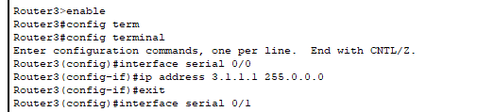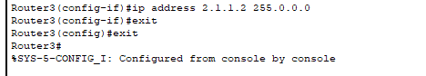

Showing IP addresses

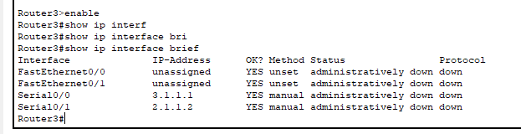

For Router4 (Serial 0/0, Serial 0/1, FastEthernet 0/0)
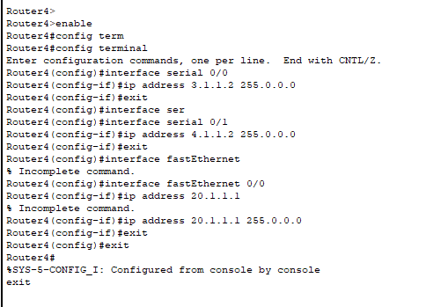

Showing IP addresses

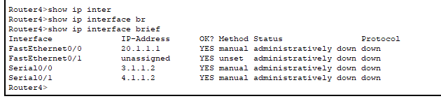

IP and Gateway for PC1 (Fast 0)
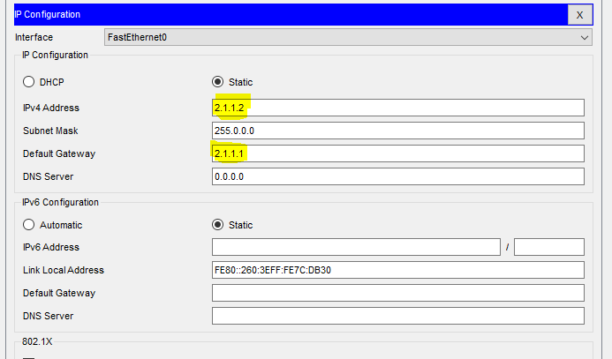

IP and Gateway for PC2 (Fast 0)
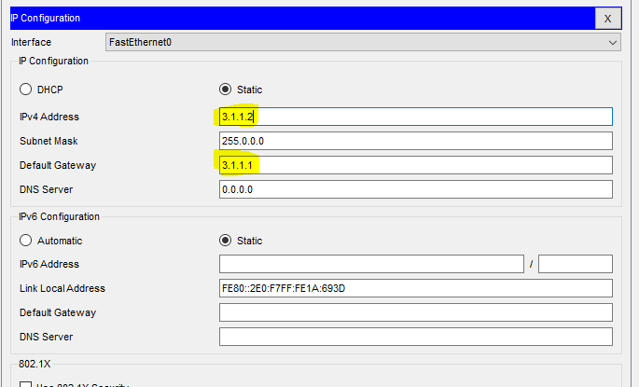

NOTE: By default, interfaces are shutdown, so we need to up it.
For Router1 - S 0/0, S 0/1, F 0/0

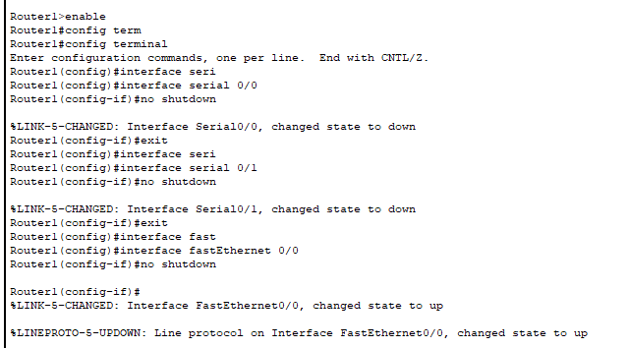

Now checking

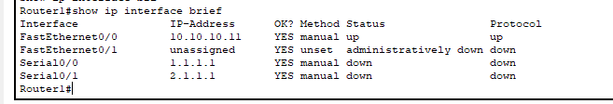

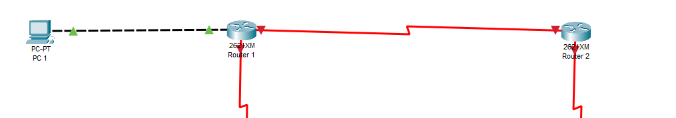

For Router2 - S 0/0, S 0/1
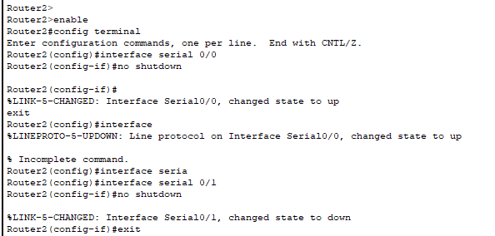

Now Checking

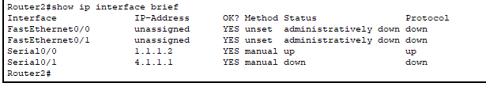
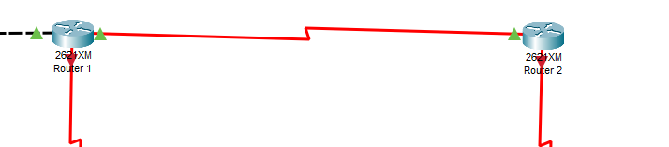

For Router3 - S 0/0, S 0/1

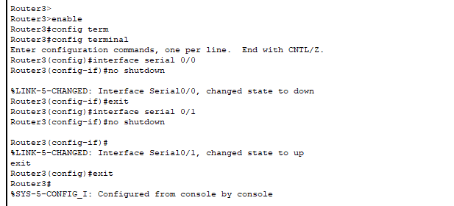

Now checking

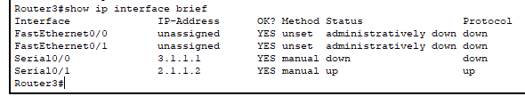

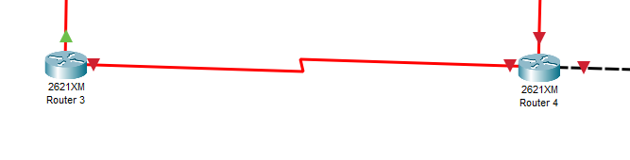

For Router4 - S 0/0, S 0/1 and F 0/0

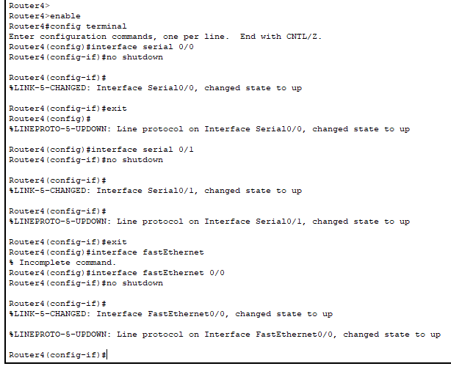

Now checking

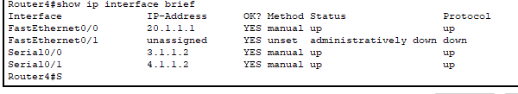

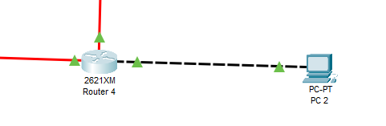
We can see, now the routers and PCs links are green, which means it is configured correctly.

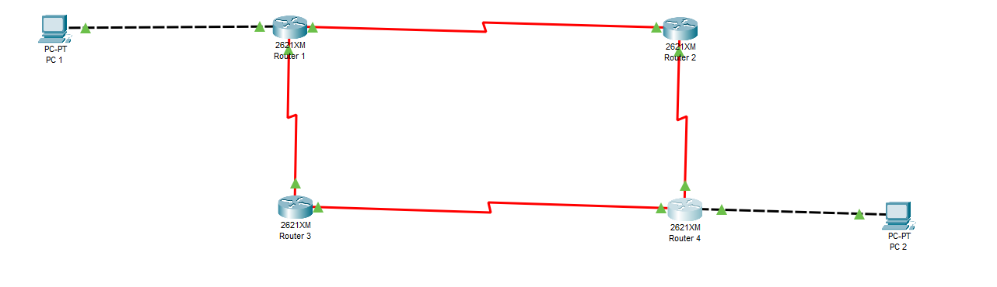

NOTE: Now all links are up. But there is a lot of IP addresses are missing, we need to assign it.

On Router1 we have following connection
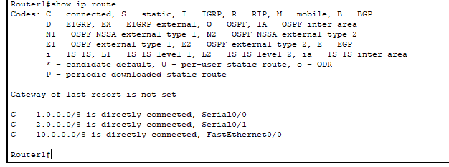

So missing networks are 3.0.0.0, 4.0.0.0, 20.0.0.0,
Let’s advertise missing networks using RIP version 2.

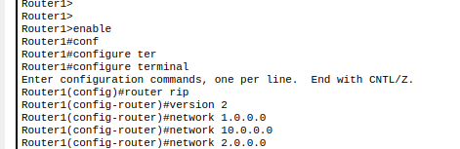

To check
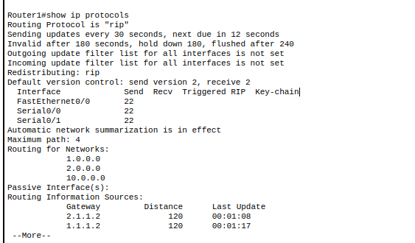
On Router2
So missing networks are 3.0.0.0, 4.0.0.0, 20.0.0.0, 10.0.0.0
Let’s advertise missing networks

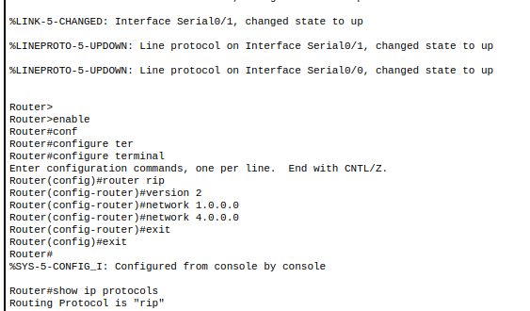

To check
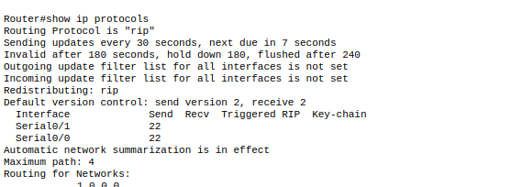
On Router3
So missing networks are 1.0.0.0, 4.0.0.0, 20.0.0.0, 10.0.0.0
Let’s advertise missing networks
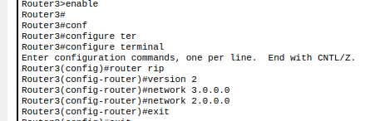
To check
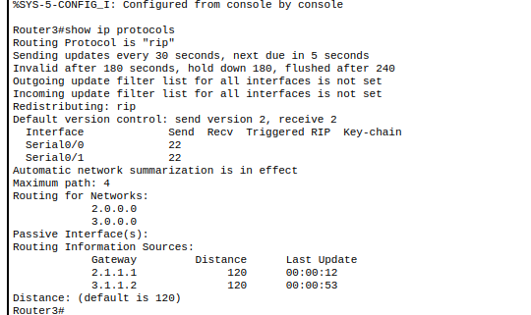

On Router4
So missing networks are 1.0.0.0, 2.0.0.0, 10.0.0.0
Let’s advertise missing networks, we just need to use directly connected networks the rest will be automatically
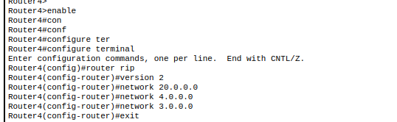
To check
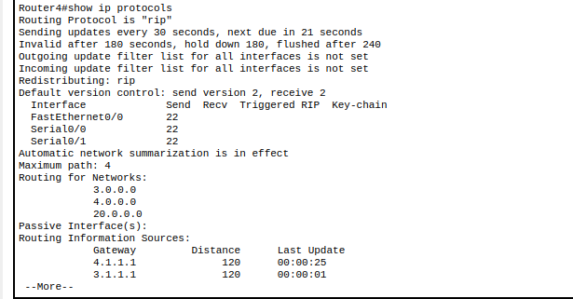

ALL DONE, NOW CHECKING FOR COMMUNICATION

Now checking all the links – pinging all with each other
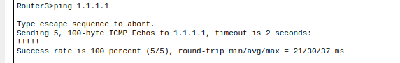

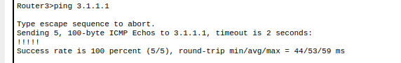

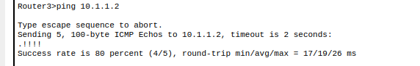

The above pinging shows that all the devices are connected and communicating successfully with each other.
The End

